AIM: TO ANALYSE APPLICATION LAYER PACKETS (DNS & HTTP)
(Using a packet tracer tool, i.e. , Wireshark)
- Generate DNS traffic from the web browser:
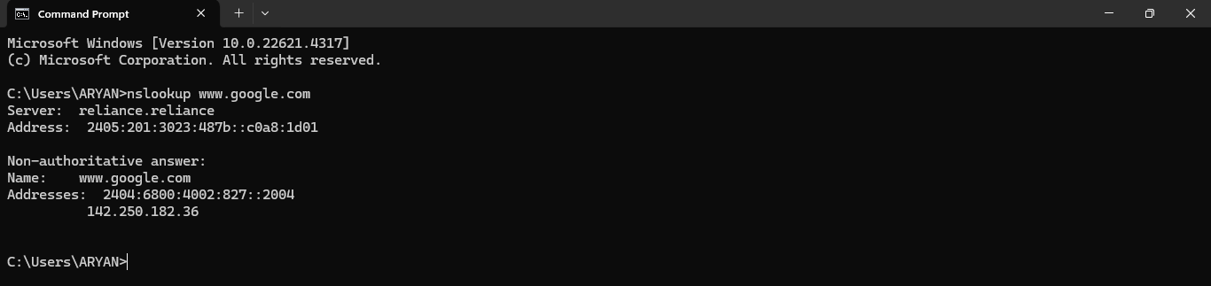

- Capture and analyse DNS & HTTP packets:




